EXPT. NO: 16 | TOWER OF HANOI
DATE: | TOWER OF HANOI
Aim:
To write a C program for tower of hanoi using recursion
Algorithm
- START
- PRINT Enter Number Of disk:
- GET n
- CALL FUNCTION towerOfHanoi(n, 'A', 'C', 'B')

- IF n == 1
- PRINT Move disk 1 from rod [from_rod] to rod [to_rod]
- RETURN
- CALL FUNCTION towerOfHanoi(n-1, from_rod, aux_rod, to_rod)
- PRINT Move disk [n] from rod [from_rod] to rod [to_rod]
- CALL FUNCTION towerOfHanoi(n-1, aux_rod, to_rod, from_rod)
- RETURN
Program
#include<stdio.h>
int towerOfHanoi(int n, char from_rod, char to_rod, char aux_rod) {
if (n == 1) {
printf("\nMove disk 1 from rod %c to rod %c", from_rod, to_rod);
return;
}
towerOfHanoi(n-1, from_rod, aux_rod, to_rod);
printf("\nMove disk %d from rod %c to rod %c", n, from_rod, to_rod);
towerOfHanoi(n-1, aux_rod, to_rod, from_rod);
return;
}
int main() {
int n;
printf("Enter Number Of disk: ");
scanf("%d", &n);

towerOfHanoi(n, 'A', 'C', 'B');
return 0;
}
Output
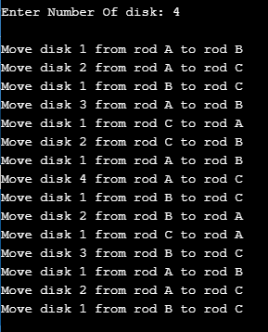

Result
Thus the C program for tower of hanoi using recursion was executed successfully.

